# Brandon Hogue

# IR Receiving Data Sheet

This module takes IR from an external emitter, and outputs demodulated IR to the PIC microcontroller.

# Schematic:

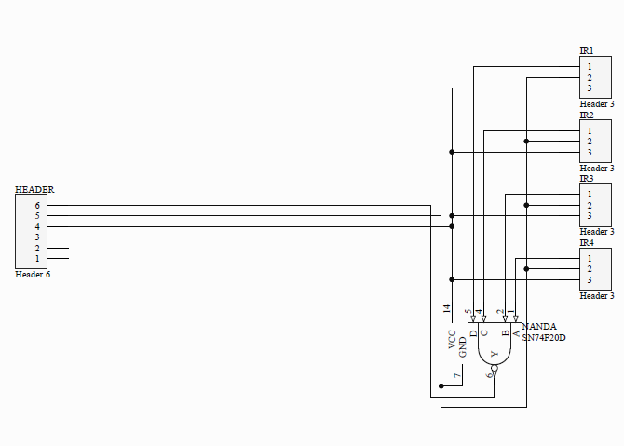

# PCB Layout:

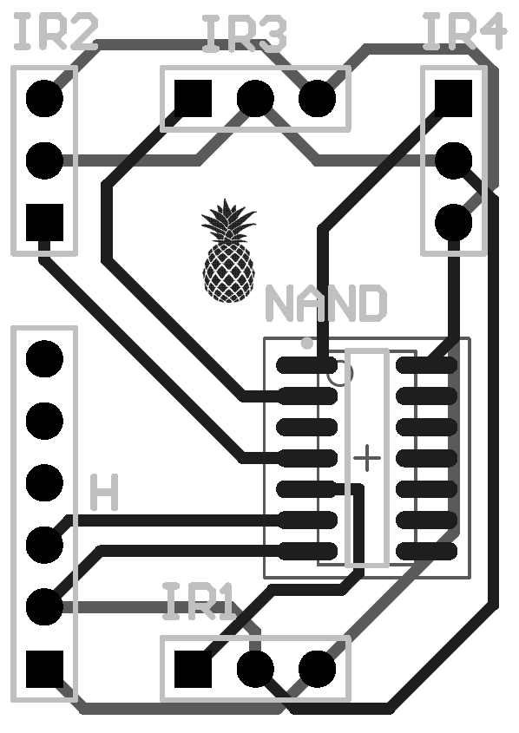

# Hardware Inputs:

|  |  |  |
| --- | --- | --- |
| Input Name | Description of Signal | Expected Range |
| 5V | --- | Up to 10mA |
| GND | --- | --- |
|  |  |  |
|  |  |  |

|  |  |  |
| --- | --- | --- |
| Output Name | Description of Signal | Expected Range |
| IR Out | Active High Demodulated IR Signal | 0V OR 5V |
|  |  |  |
|  |  |  |
|  |  |  |

# Software:

|  |  |  |  |
| --- | --- | --- | --- |
| Function Name | Description | Input Parameters | Return Value |
| ISR | Christian’s ISR block | Digital H/L | Packet Type |
|  |  |  |  |
|  |  |  |  |
|  |  |  |  |
|  |  |  |  |

# Time Dependent Output: